Harry Gwala District Municipality

MFMA s71 report for the period ending 31 July 2019.

8/15/2019

Budget & Treasury Office

Table of Contents

**1.1** **PURPOSE** 3

1.2 EXECUTIVE SUMMARY 3

**DELIBERATION** 4

1.3 Resolutions 4

1.4 Monthly Budget Statement Tables 4

2.1 Debtors Analysis 14

2.2 Creditors Analysis 19

2.3 Investment Portfolio Analysis 20

2.4 Allocation and Grant receipts and Expenditure 21

2.5 Councillor and Staff Benefits 22

2.6 Material Variances to the SDBIP 24

2.7 Municipal Manager’s Quality’s Certificate 35

**REPORT ON S71 OF THE MFMA FOR THE PERIOD ENDING 31 JULY 2019**

1. **PART 1 – MONTHLY REPORT**
   1. **PURPOSE**

To table a report on the Implementation of the current budget and the financial state of the Municipality in terms of Section 71 of the Municipal Finance Management Act (MFMA)

**LEGAL FRAMEWORK**

* Local Government: Municipal Finance Management Act, 56 of 2003
* SCM Regulations
* SCM Policy
* Municipal Budget Reporting Regulation
* Division of Revenue Act

## 1.2 EXECUTIVE SUMMARY

**Legislative Requirements**

In terms of the section 71 of the MFMA the accounting officer of a municipality must by no later than 10 working days after the end of each month submit to the Mayor of the municipality and the relevant provincial treasury a statement in the prescribed format on the state of the municipality’s budget reflecting the following particulars for that month and for the financial year up to the end of that month:

*(a)* Actual revenue, per revenue source;

*(b)* actual borrowings;

*(c)* actual expenditure, per vote;

*(d)* actual capital expenditure, per vote;

*(e)* the amount of any allocations received;

*(f)* actual expenditure on those allocations, excluding expenditure on—

(i) its share of the local government equitable share; and

(ii) allocations exempted by the annual Division of Revenue Act from compliance with this paragraph; and

*(g)* when necessary, an explanation of—

(i) any material variances from the municipality’s projected revenue by source, and from the municipality’s expenditure projections per vote;

(ii) any material variances from the service delivery and budget implementation plan; and

(iii) any remedial or corrective steps taken or to be taken to ensure that projected revenue and expenditure remain within the municipality’s

**DELIBERATION**

The discussion that follows, in terms of MFMA Section 71 above, intends to inform the Executive committee and Executive Council on the progress made thus far in terms of implementing the 2019/2020 budget for the period ending 31 July 2019.

## Resolutions

This report will be tabled to Executive committee and therefore the resolution will be available once it tabled to council in terms of Sec 52 (d) of the MFMA.

## Monthly Budget Statement Tables

**Monthly Budget Statements Summary**

Table C1 below provides a summary of the overall performance in the Municipality and is unpacked in the sections that follow.



**Financial Performance**

Table C2 provides the statement of financial performance by standard classification.



This table assess the revenue by department and then the expenditure for the period ending 31 July 2019. Revenue receipts in July have largely constituted of equitable share followed by service charges which is water and sanitation. The overall budgeted revenue cash receipt for the month of July is 20%.

Expenditure by standard classification presents the expenditures by the departments. Water Services Department has largest expenditure by 30% in the period ending 31 July 2019. This being largely attributable to the backlog demand of operations and maintenance of water schemes in the District.

Table C3 presents the same information as the table above, the difference being that it’s by Municipal vote.



**Statement of financial Performance**

This schedule provides information on the planned revenue and operational expenditures against the actual results for the period ending 31 July 2019.



**Capital Expenditure**

Table C5 below reports on the capital expenditures by departments (municipal vote) and also by standard classification. The bottom part of the schedule looks at the funding sources of the capital projects.



As alluded to above, the capital expenditure programme for the month ending 31 July was R15, 1m of capital expenditure against year to date budget.

The chart below presents a high level analysis of YTD capital expenditure budget against the YTD actual expenditure.

**Chart 1: 2019/2020 CAPEX YTD BUDGET & YTD ACTUAL**

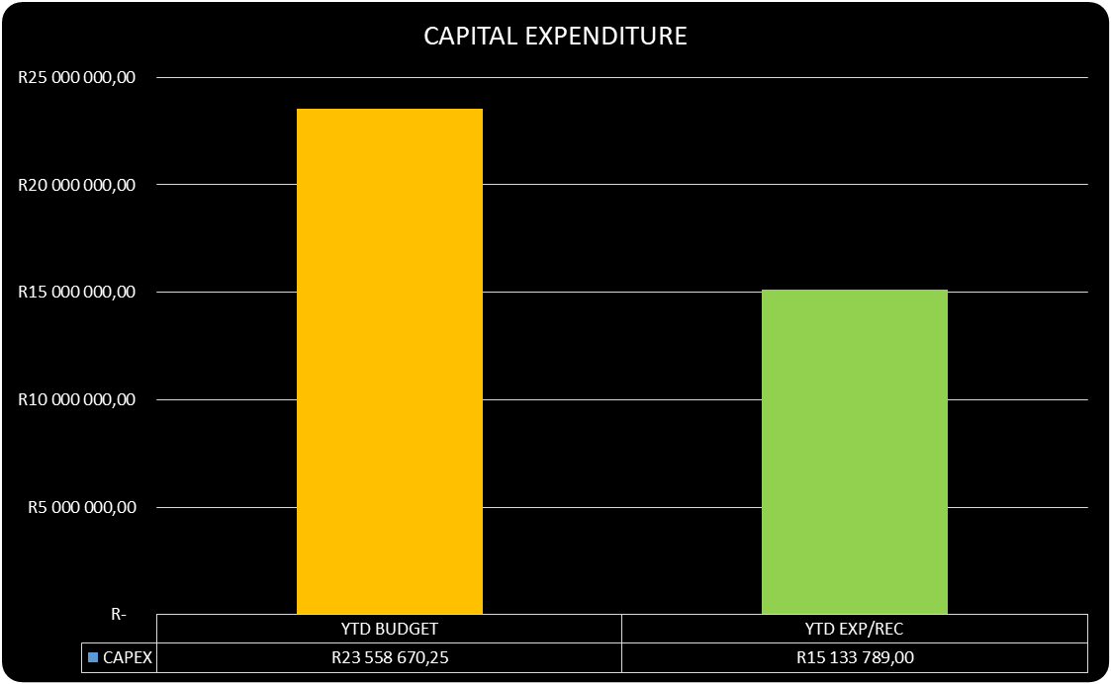

As at 31 July 2019, the year to date actual expenditure was R15, 1million against a YTD budget of R23, 5million. In monetary terms, these figures represent 64% per cent performance against the capital development programme as at 31 July 2019.

Table C6 displays the financial position of the municipality as at 31 July 2019.



Table C7 below display the Cash Flow Statement for the period ending 31 July 2019.



**PART 2 – SUPPORTING DOCUMENTATION**

## Debtors Analysis

The table presented below summarises the Debtors Age Analysis as at 31 July 2019.

**Table 2.1.1: Debtors Age Analysis by Income Source**



The municipal consumer debt is currently increasing citing rigorous actions to ensure that this trend is prevented from continuing as it has a direct negative impact on municipal cash flows.

**Chart 2: Debtors Age Analysis by Customer Group**

The information presented in the chart above ranks total debt owed to the municipality from highest to the lowest,

* Households: 89%
* Government 5%
* Business 6%

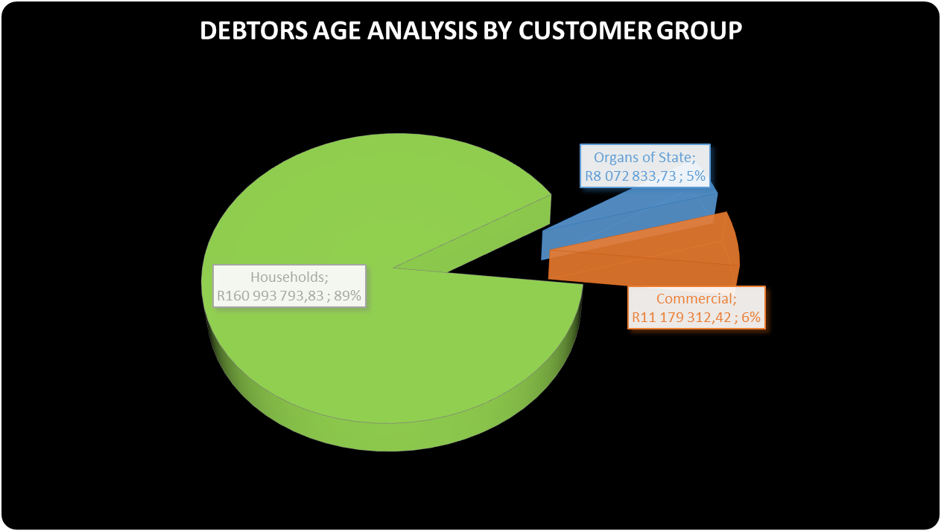

The chart above shows that for each debtor type the amounts owing to the municipality have increased on a year to year basis.

The table that follows below unpacks the revenue receipts per Local Municipality in the District

**REVENUE RECEIPTS**

**Revenue receipts per Area**

|  |  |  |
| --- | --- | --- |
| AREA | AMOUNT |  |
| **JULY 2019** | **JUNE 2019** |
| Unallocated receipts | R 470 136 .00 | 10% | 7% |
| Bhongweni | R 31 175.76 | 6% | 0% |
| Shayamoya | R 1 548.00 | 0% | 1% |
| Kokstad | R 2 327 236.23 | 49% | 56% |
| Ixopo | R 1 410 028.03 | 30% | 19% |
| NDZ | R 314 848.40 | 7% | 12% |
| Umzimkulu | R 216 562.37 | 5% | 4% |
| Fairview | R  1 519.15 | 0% | 0% |
| TOTAL RECEIPTS INCL VAT | **R 4 773 053.94** | 100% | 100% |

The table above presents the cash receipts from consumer debtors in each of the detailed areas as well as the comparative receipts for the previous month. The total cash collected for July 2019 is R4, 7million

**BILLING VS COLLECTION (COMPARISON BETWEEN JUNE 2019 AND JULY 2019)**

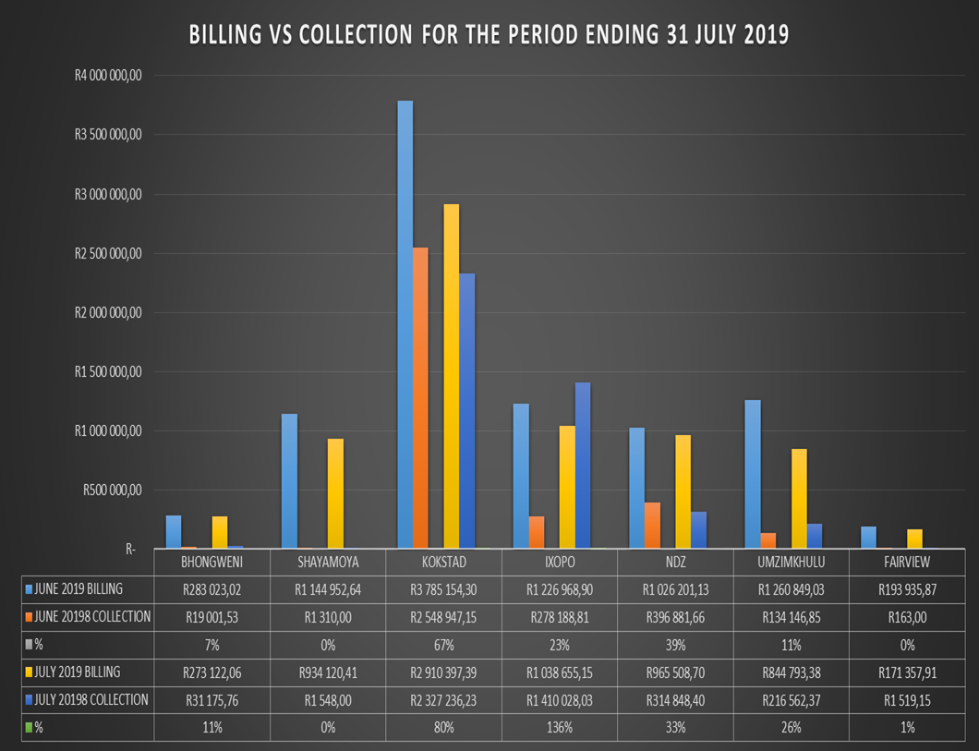

**BILLING VS COLLECTION TREND FOR JUNE AND JULY 2019**

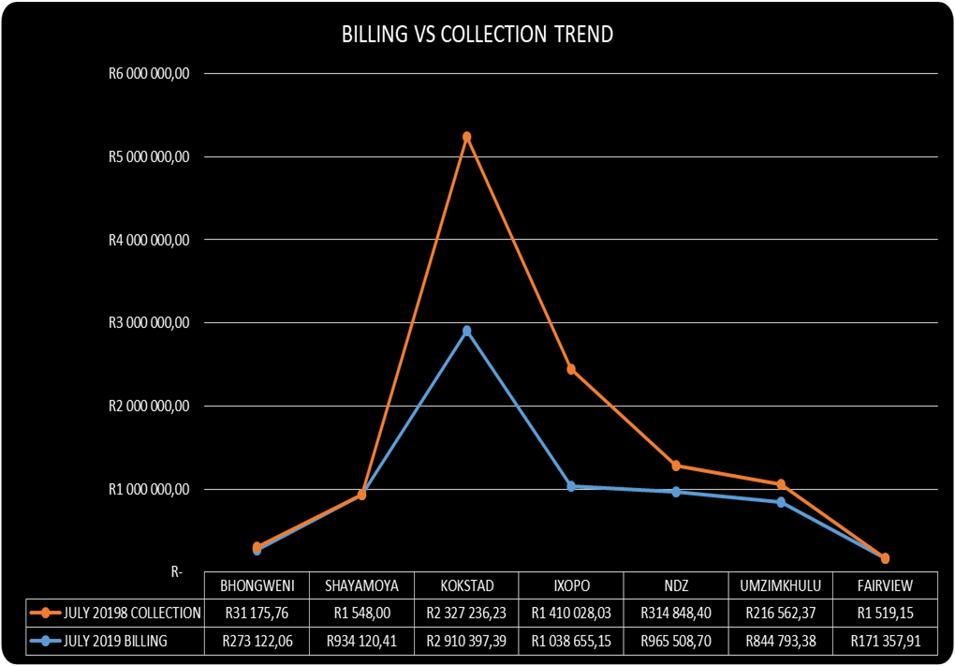

**Debtors age analysis per service**

The municipality’s total outstanding debtors amounted to R 180 245 939 as at 31 July 2019 compared with the R 177 643 480 as at 30 June 2019. Current debt represent 4% of the total outstanding debt compared with the 5% of June 2019; 30 days and older debt 4% compared with the 4% for June 2019; 60 days and older debt 3% compared with the 3% of June 2019; and 90 days 3% compared with the 3% of June 2019; 160 days to History and older 86% compared with the 85% for June 2019.

Current debt decreased with R 2,602,460 to R 180,245,940 compared with the R 177,643,480 as at 30 June 2019; 30 days + debt Decreased with R 99,208K; 60 days + Decreased with R 350,473 and 90 days and older debt as at July 2019 has increased with R 3,552,018 to R 160,111,466 compared with the R 156,559,449 as at 30 June 2019.

**Debtors age analysis per debtor type**

Business debtors owes the municipality R 10,843,457 (6%); Municipal debtors R 752,315 (0.01%); domestic debtors R 132,884,529 (74%); Government accounts R 7,156,901 (4%); Indigent debtors R 25,437,579 (14%) and other debtors R 3,171,158 (2%) of the total outstanding debt of R 177,643,480. Furthermore most of the domestic debt and other debt will be irrecoverable and most probably will also have to be written off.

## Creditors Analysis

Table SC presents the aged creditors as at 31 July 2019.



## Investment Portfolio Analysis

The following information presents the cash at bank and short term investments balances broken down per investment type as at 31 July 2019.

**Cash and Bank Balances (Investments)**



## Allocation and Grant receipts and Expenditure

Table SC 6 displays information relating to grant receipts.



It is clear from the chart above that the bulk of the grants received by the municipality are from the National Treasury.

Table SC7 track the expenditure on Conditional grant funding.



## Councillor and Staff Benefits

Table SC8 presents the expenditure of councillor and staff benefits at 31 July 2019.



## Material Variances to the SDBIP

The following section analyses material variances between the actual targets as at 31 July 2019 and the budget for the same period. This report analyses each major component under following headings;

* Revenue by Source
* Operational Expenditure by Type, and
* Capital Expenditure
* Financial Position
* Cash Flows

**REVENUE**

The chart displays a comparison between the 201920 financial year revenue budget and the performance against this budget as depicted in the form of Year to date (YTD) Actual figures. It should be emphasised that the information presented relates to “performance” rather that “cash movements” in terms of the revenue items listed below. This accounting principle relating to municipal performance is best illustrated in the analysis that follows.

**Chart 3: Revenue Analysis**

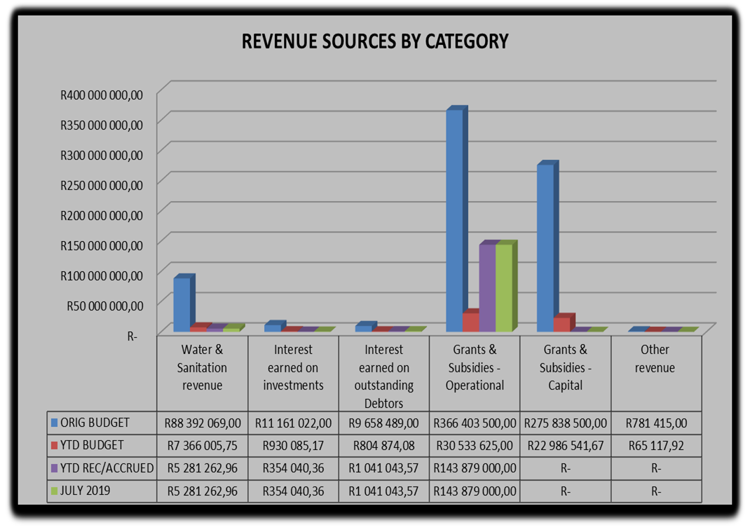

**Water & Sanitation Charges**

The year to date **actual** water & sanitation charges **(billing)** as at 31 July 2019 was R5, 2million against a year to date **budget** of R7, 3million.

**Interest Earned on External Investments**

The actual interest earned on external investments as at 31 July 2019 is R 354 040k against year to date budget of R930 085k. This represent 38% of monthly received against year to date budget.

**Transfers Recognised – Operational**

Two operational grants received for the month of July 2019 namely;

* Equitable Share- R 143 879 000
* Expanded Public Works Programme- R 1 329 000

**Transfers Recognised – Capital**

The actual R15, 1million (against a YTD budget of R23, 5million) represent the conditions met in capital expenditures against the conditional grant allocation received. This amount represents 64% performance in Conditional Capital grant funding expenditures.

One Capital grant received namely:

* Municipal Water Infrastructure Grant- R 50 000 000

**Other Revenue**

The is no movement for other revenue in the month ending 31 July 2019.The YTD budget is R65 118k for the month ending 31 July 2019.

**OPERATIONAL EXPENDITURE**

The chart below presents the YTD operational expenditure movements against the YTD budgets. An analysis of each expenditure line item category is discussed below.

**Chart 4: 2019/20 financial year Operational expenditure**

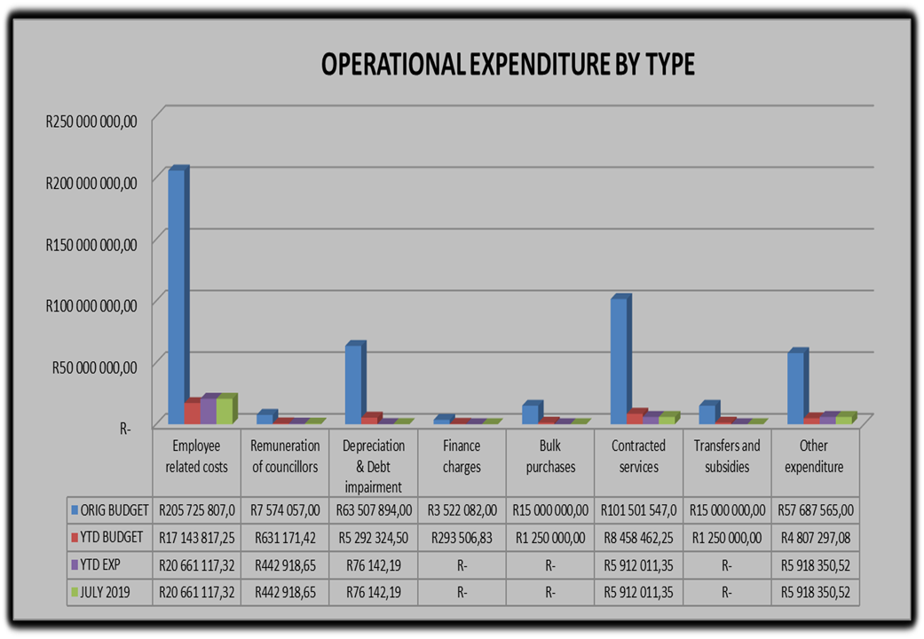

**Employee Related Costs**

The YTD budget for employee related costs is R17, 1million against a YTD actual of R20, 6million which is 10% of the original budget

**Remuneration of Councillors**

The remuneration of councillor’s year to date expenditure is at R 442 919k against a YTD budget of R7, 5million representing 6% of the original budget.

**Finance Charges**

As at 31 July 2019, there was no expenditure incurred for finance charges. The budgeted amount for finance charges was R3, 5million.

**Bulk Purchases**

The year to date expenditure on Bulk Water purchases has the budget of R15million and there was no expenditure incurred for bulk water purchases.

**Other Expenditure**

The YTD budget for other expenditure was at R 4, 8milllion against a YTD expenditure of R 5, 9million and expenditure for the month of July 2019 representing 10 per cent of the original budget.

**Performance assessment**

The Performance Assessment Report will be available on the second quarter of 2019/2020 financial year in terms of mid-term performance assessment in accordance with the Municipal Finance Management Act.

**Actual and revised targets for cash receipts**



**Parent Municipal financial performance**



**Capital Expenditure Trend**



**CAPITAL EXPENDITURE MONTHLY TREND**

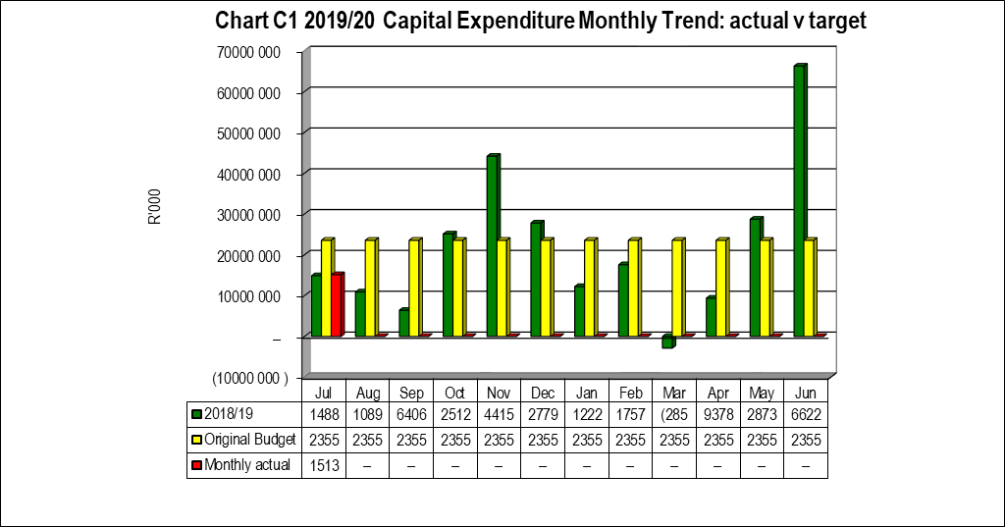

**Capital Expenditure on New Assets by Asset Class**



**Capital Expenditure on Renewal of Existing Assets by Asset Class**



## 2.7 Municipal Manager’s Quality’s Certificate

Quality Certificate

I, Adelaide Nomnandi Dlamini, the Municipal Manager of Harry Gwala District Municipality, hereby certify that-

* The monthly budget statement

For the month of July 2019 has been prepared in accordance with the Municipal Finance Management Act and regulations made under that Act.

Print name: Adelaide Nomnandi Dlamini

Municipal Manager of: Harry Gwala District Municipality

Signed____________________

Date______________________